**Data Science Salary Insights and Excel Dashboard**

**Objective:**

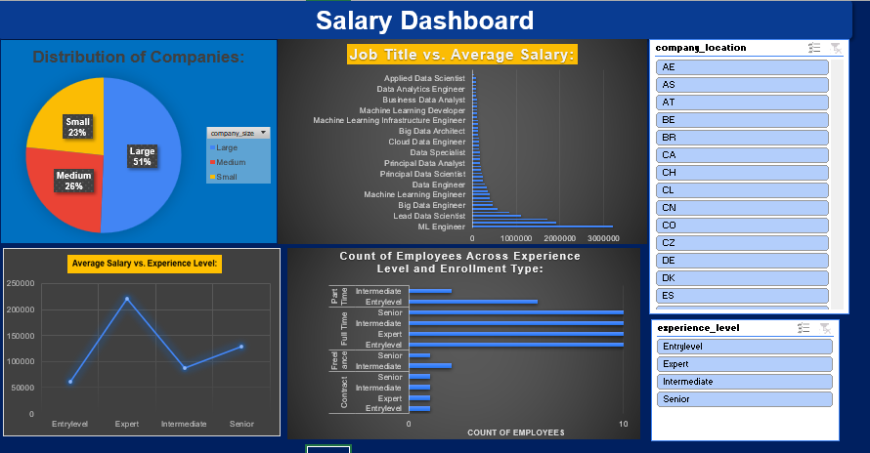The objective of the Data Science Salary Insights and Excel Dashboard is to provide a comprehensive and visually appealing analysis of salary trends in the field of Data Science. The project aims to gather, process, and present relevant salary data to help professionals .

**Insights from Salary Dashboard Analysis**

1. **Distribution of Companies by Size**  
   The analysis indicates that large companies constitute the majority of employers in the Data Science sector, representing **51%** of the total. Medium-sized companies account for **26%**, while small companies contribute **23%**. This distribution suggests that employment opportunities for Data Science professionals are predominantly concentrated in large organizations, which are likely to have greater resources, larger datasets, and more advanced analytics requirements.
2. **Job Title and Average Salary Trends**  
   A comparison of job titles against average salaries reveals that **Machine Learning Engineers** and **Lead Data Scientists** are among the highest-paid roles, with average salaries exceeding **$300,000**. Other technical positions such as **Data Engineers**, **Principal Data Analysts**, and **Big Data Engineers** also command high remuneration. In contrast, roles such as **Business Data Analysts** and **Applied Data Scientists** receive comparatively lower compensation, highlighting a premium placed on engineering-focused skill sets in the Data Science field.
3. **Average Salary by Experience Level**  
   In Data Science, salaries increase consistently with experience, showing a strong positive correlation between expertise and earning potential. Entry-level professionals earn around **$60K**, while Experts command salaries exceeding **$220K**, highlighting that advanced skills and seniority significantly amplify compensation—especially at the top tiers.
4. **Employee Count Across Experience Levels**  
   The workforce distribution shows that the majority of employees operate at the **Intermediate** and **Senior** levels, primarily in **full-time** positions. Entry-level and Expert-level roles are less prevalent, suggesting either limited availability or a higher barrier to entry for these categories.
5. **Geographic Scope**  
   The dataset encompasses hiring activity across multiple countries. While the dashboard allows for geographic filtering (e.g., BR, CA, CH, CO), location-specific salary variations can be further explored to provide deeper insights into regional market dynamics.

**Subjective Questions :-**

* **Distribution of Companies:**

1. **How is the distribution of company sizes in the Data Science job market? Are certain company sizes more prevalent in hiring Data Science professionals?**

The distribution of company sizes in the Data Science job market shows that:

* Large companies account for 51% of hiring.
* Medium companies account for 26%.
* Small companies account for 23%.

This indicates that large companies dominate the hiring market for Data Science professionals, offering more than half of the total job opportunities. Medium-sized companies contribute a moderate share, while small companies make up the smallest portion. Large organizations often have bigger budgets, larger datasets, and established data teams, making them more likely to invest heavily in Data Science roles.

* **Job Title vs. Average Salary:**

1. **Which job titles command higher average salaries in the Data Science field? Can we identify specific roles that offer more competitive compensation?**

Job titles that command higher average salaries in the Data Science field include:

* **Machine Learning Engineer** – consistently among the top earners, with average salaries exceeding $300,000.
* **Lead Data Scientist** – also positioned at the upper end of the salary spectrum.
* **Big Data Engineer and Principal Data Analyst** – offer strong compensation packages.
* **Data Engineer** – competitive salaries, though slightly below the very top roles.

*These findings indicate that engineering-focused and senior technical roles (especially those in machine learning and big data) tend to offer more competitive compensation compared to analytical or reporting-focused positions such as Business Data Analyst or Applied Data Scientist.*

1. **Are there differences in employee counts based on experience levels and enrollment types? Does the hiring trend favour full-time or part-time employees at different experience levels?**

Yes, there are clear differences in employee counts across experience levels and enrollment types. The data shows that **full-time employment dominates**, with 285 out of 300 employees (95%) working full time. Among them, **Intermediate-level professionals** form the largest group (121 employees), followed by Senior (92), Entry-level (60), and Expert (12).

In contrast, **part-time, contract, and freelance roles are rare**:

* **Part-time**: Only 8 employees (mostly Entry-level and Intermediate)
* **Contract**: 4 employees spread evenly across all experience levels (1 each)
* **Freelance**: 3 employees (Intermediate and Senior only)

This indicates that the hiring trend strongly favors **full-time roles across all experience levels**, with very limited opportunities for part-time, contract, or freelance positions. Intermediate and Senior professionals are particularly sought after for full-time work.

1. **How do average salaries vary with experience levels in Data Science? Is there a clear correlation between experience and earning potential?**

From the data:

* Entry Level → Avg. salary ≈ $60,459
* Intermediate → Avg. salary ≈ $87,179
* Senior → Avg. salary ≈ $128,075
* Expert → Avg. salary ≈ $220,470

Analysis:  
There is a clear positive correlation between experience level and earning potential in Data Science. Salaries rise steadily as experience increases, with Experts earning over 3.6 times more than Entry-level employees. The biggest jump appears between Senior and Expert roles, indicating that highly specialized skills and leadership responsibilities significantly boost pay.